<https://towardsdatascience.com/object-detection-with-tensorflow-model-and-opencv-d839f3e42849>

import tensorflow_hub as hub

import cv2

import numpy

import pandas as pd

import tensorflow as tf

import matplotlib.pyplot as plt

width = 1028

height = 1028

#Load image by Opencv2

img = cv2.imread('test.jpeg')

#Resize to respect the input_shape

inp = cv2.resize(img, (width , height ))

#Convert img to RGB

rgb = cv2.cvtColor(inp, cv2.COLOR_BGR2RGB)

# COnverting to uint8

rgb_tensor = tf.convert_to_tensor(rgb, dtype=tf.uint8)

#Add dims to rgb_tensor

rgb_tensor = tf.expand_dims(rgb_tensor , 0)

import tensorflow_hub as hub

import pandas as pd

# Loading model directly from TensorFlow Hub

detector = hub.load("https://tfhub.dev/tensorflow/efficientdet/lite2/detection/1")

# Loading csv with labels of classes

labels = pd.read_csv('labels.csv', sep=';', index_col='ID')

labels = labels['OBJECT (2017 REL.)']

# Creating prediction

boxes, scores, classes, num_detections = detector(rgb_tensor)

# Processing outputs

pred_labels = classes.numpy().astype('int')[0]

pred_labels = [labels[i] for i in pred_labels]

pred_boxes = boxes.numpy()[0].astype('int')

pred_scores = scores.numpy()[0]

# Putting the boxes and labels on the image

for score, (ymin,xmin,ymax,xmax), label in zip(pred_scores, pred_boxes, pred_labels):

    if score < 0.5:

        continue

    score_txt = f'{100 * round(score)}%'

    img_boxes = cv2.rectangle(rgb,(xmin, ymax),(xmax, ymin),(0,255,0),2)

    font = cv2.FONT_HERSHEY_SIMPLEX

    cv2.putText(img_boxes, label,(xmin, ymax-10), font, 1.5, (255,0,0), 2, cv2.LINE_AA)

    cv2.putText(img_boxes,score_txt,(xmax, ymax-10), font, 1.5, (255,0,0), 2, cv2.LINE_AA)

plt.imshow(img_boxes)

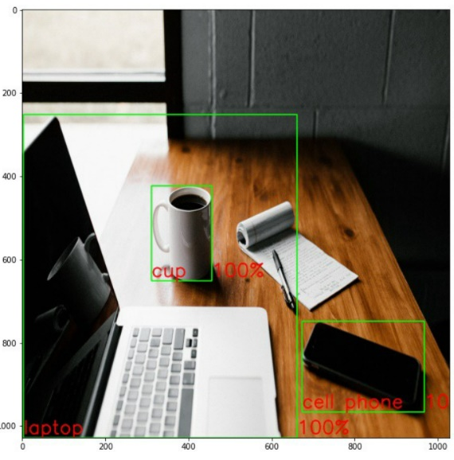

**Live Webcam Video**

Now we can move on to detecting objects live using the webcam on your pc.

This part is not as hard as it seems, we just have to insert the code we used for one image in a loop:

from IPython.display import display, Javascript

from google.colab.output import eval_js

from base64 import b64decode

def take_photo(filename='photo.jpg', quality=0.8):

  js = Javascript('''

    async function takePhoto(quality) {

      const div = document.createElement('div');

      const capture = document.createElement('button');

      capture.textContent = 'Capture';

      div.appendChild(capture);

      const video = document.createElement('video');

      video.style.display = 'block';

      const stream = await navigator.mediaDevices.getUserMedia({video: true});

      document.body.appendChild(div);

      div.appendChild(video);

      video.srcObject = stream;

      await video.play();

      // Resize the output to fit the video element.

      google.colab.output.setIframeHeight(document.documentElement.scrollHeight, true);

      // Wait for Capture to be clicked.

      await new Promise((resolve) => capture.onclick = resolve);

      const canvas = document.createElement('canvas');

      canvas.width = video.videoWidth;

      canvas.height = video.videoHeight;

      canvas.getContext('2d').drawImage(video, 0, 0);

      stream.getVideoTracks()[0].stop();

      div.remove();

      return canvas.toDataURL('image/jpeg', quality);

    }

    ''')

  display(js)

  data = eval_js('takePhoto({})'.format(quality))

  binary = b64decode(data.split(',')[1])

  with open(filename, 'wb') as f:

    f.write(binary)

  return filename

import tensorflow_hub as hub

import cv2

import numpy

import tensorflow as tf

import pandas as pd

# Carregar modelos

detector = hub.load("https://tfhub.dev/tensorflow/efficientdet/lite2/detection/1")

labels = pd.read_csv('labels.csv',sep=';',index_col='ID')

labels = labels['OBJECT (2017 REL.)']

#cap = cv2.VideoCapture(0)

width = 512

height = 512

while(True):

#Capture frame-by-frame

#ret, frame = cap.read()

frame = take_photo()

#Resize to respect the input_shape

inp = cv2.resize(frame, (width , height ))

#Convert img to RGB

rgb = cv2.cvtColor(inp, cv2.COLOR_BGR2RGB)

#Is optional but i recommend (float convertion and convert img to tensor image)

rgb_tensor = tf.convert_to_tensor(rgb, dtype=tf.uint8)

#Add dims to rgb_tensor

rgb_tensor = tf.expand_dims(rgb_tensor , 0)

boxes, scores, classes, num_detections = detector(rgb_tensor)

pred_labels = classes.numpy().astype('int')[0]

pred_labels = [labels[i] for i in pred_labels]

pred_boxes = boxes.numpy()[0].astype('int')

pred_scores = scores.numpy()[0]

#loop throughout the detections and place a box around it

for score, (ymin,xmin,ymax,xmax), label in zip(pred_scores, pred_boxes, pred_labels):

if score < 0.5:

continue

score_txt = f'{100 * round(score,0)}'

img_boxes = cv2.rectangle(rgb,(xmin, ymax),(xmax, ymin),(0,255,0),1)

font = cv2.FONT_HERSHEY_SIMPLEX

cv2.putText(img_boxes,label,(xmin, ymax-10), font, 0.5, (255,0,0), 1, cv2.LINE_AA)

cv2.putText(img_boxes,score_txt,(xmax, ymax-10), font, 0.5, (255,0,0), 1, cv2.LINE_AA)

#Display the resulting frame

cv2.imshow('black and white',img_boxes)

if cv2.waitKey(1) & 0xFF == ord('q'):

break

# When everything done, release the capture

cap.release()

cv2.destroyAllWindows()

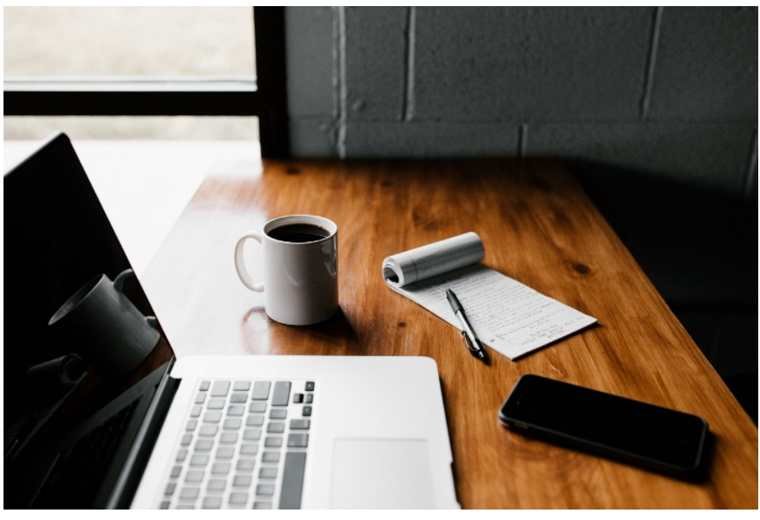

labels.csv

ID;OBJECT (PAPER);OBJECT (2014 REL.);OBJECT (2017 REL.);SUPER CATEGORY

1;person;person;person;person

2;bicycle;bicycle;bicycle;vehicle

3;car;car;car;vehicle

4;motorcycle;motorcycle;motorcycle;vehicle

5;airplane;airplane;airplane;vehicle

6;bus;bus;bus;vehicle

7;train;train;train;vehicle

8;truck;truck;truck;vehicle

9;boat;boat;boat;vehicle

10;traffic light;traffic light;traffic light;outdoor

11;fire hydrant;fire hydrant;fire hydrant;outdoor

12;street sign;-;-;outdoor

13;stop sign;stop sign;stop sign;outdoor

14;parking meter;parking meter;parking meter;outdoor

15;bench;bench;bench;outdoor

16;bird;bird;bird;animal

17;cat;cat;cat;animal

18;dog;dog;dog;animal

19;horse;horse;horse;animal

20;sheep;sheep;sheep;animal

21;cow;cow;cow;animal

22;elephant;elephant;elephant;animal

23;bear;bear;bear;animal

24;zebra;zebra;zebra;animal

25;giraffe;giraffe;giraffe;animal

26;hat;-;-;accessory

27;backpack;backpack;backpack;accessory

28;umbrella;umbrella;umbrella;accessory

29;shoe;-;-;accessory

30;eye glasses;-;-;accessory

31;handbag;handbag;handbag;accessory

32;tie;tie;tie;accessory

33;suitcase;suitcase;suitcase;accessory

34;frisbee;frisbee;frisbee;sports

35;skis;skis;skis;sports

36;snowboard;snowboard;snowboard;sports

37;sports ball;sports ball;sports ball;sports

38;kite;kite;kite;sports

39;baseball bat;baseball bat;baseball bat;sports

40;baseball glove;baseball glove;baseball glove;sports

41;skateboard;skateboard;skateboard;sports

42;surfboard;surfboard;surfboard;sports

43;tennis racket;tennis racket;tennis racket;sports

44;bottle;bottle;bottle;kitchen

45;plate;-;-;kitchen

46;wine glass;wine glass;wine glass;kitchen

47;cup;cup;cup;kitchen

48;fork;fork;fork;kitchen

49;knife;knife;knife;kitchen

50;spoon;spoon;spoon;kitchen

51;bowl;bowl;bowl;kitchen

52;banana;banana;banana;food

53;apple;apple;apple;food

54;sandwich;sandwich;sandwich;food

55;orange;orange;orange;food

56;broccoli;broccoli;broccoli;food

57;carrot;carrot;carrot;food

58;hot dog;hot dog;hot dog;food

59;pizza;pizza;pizza;food

60;donut;donut;donut;food

61;cake;cake;cake;food

62;chair;chair;chair;furniture

63;couch;couch;couch;furniture

64;potted plant;potted plant;potted plant;furniture

65;bed;bed;bed;furniture

66;mirror;-;-;furniture

67;dining table;dining table;dining table;furniture

68;window;-;-;furniture

69;desk;-;-;furniture

70;toilet;toilet;toilet;furniture

71;door;-;-;furniture

72;tv;tv;tv;electronic

73;laptop;laptop;laptop;electronic

74;mouse;mouse;mouse;electronic

75;remote;remote;remote;electronic

76;keyboard;keyboard;keyboard;electronic

77;cell phone;cell phone;cell phone;electronic

78;microwave;microwave;microwave;appliance

79;oven;oven;oven;appliance

80;toaster;toaster;toaster;appliance

81;sink;sink;sink;appliance

82;refrigerator;refrigerator;refrigerator;appliance

83;blender;-;-;appliance

84;book;book;book;indoor

85;clock;clock;clock;indoor

86;vase;vase;vase;indoor

87;scissors;scissors;scissors;indoor

88;teddy bear;teddy bear;teddy bear;indoor

89;hair drier;hair drier;hair drier;indoor

90;toothbrush;toothbrush;toothbrush;indoor

91;hair brush;-;-;indoor